“Best” Font Size for Desktop vs Mobile
There’s no single “best” font size for desktop vs mobile — but there are industry-standard ranges that consistently feel right.

Desktop
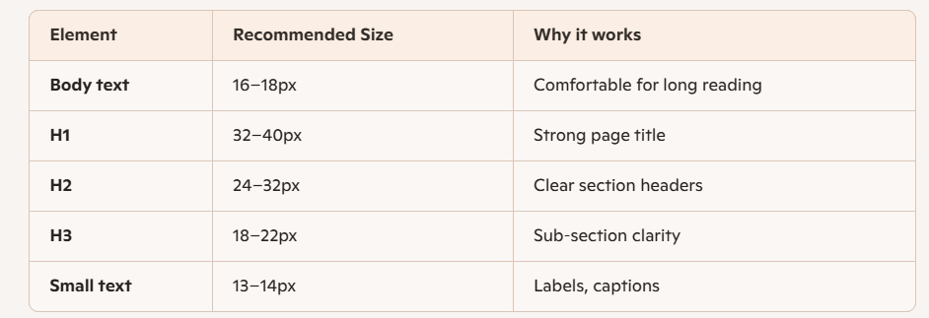
Desktop screens sit farther away, so slightly larger text improves readability.

Mobile
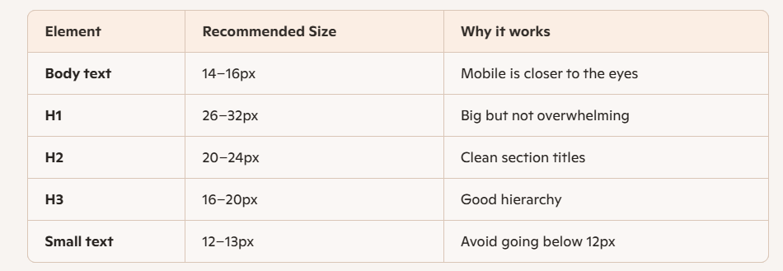
These sizes match what you see in Apple, Google, and modern web apps.

Here’s a typography system you can drop straight into your CSS
/* Desktop */
body { font-size: 16px; }
h1 { font-size: 2.5rem; }
h2 { font-size: 2rem; }
h3 { font-size: 1.5rem; }
p { font-size: 1rem; }

/* Mobile */
@media (max-width: 550px) {
body { font-size: 15px; }
h1 { font-size: 2rem; }
h2 { font-size: 1.6rem; }
h3 { font-size: 1.3rem; }
p { font-size: 0.95rem; }
}

This gives you a clean, readable, professional look on both screens.

Want the best modern approach? Use clamp()
The clamp() CSS function lets you set a value that’s responsive but stays within a minimum and maximum range.
clamp(min, preferred, max)
- min - The smallest allowed value (can be px, em, %, etc.).
- preferred - a fluid value (usually vw) that grows/shrinks with screen size
- max - The largest allowed value.
h1 { font-size: clamp(2rem, 5vw, 3rem); }
h2 { font-size: clamp(1.6rem, 4vw, 2.2rem); }
p { font-size: clamp(0.95rem, 2vw, 1.1rem); }

No media queries needed — it just works.
Why designers love clamp()
- No need for multiple media queries
- Smooth scaling between mobile and desktop
- Perfect for headings and body text
- Works in all modern browsers

